The Main Menu

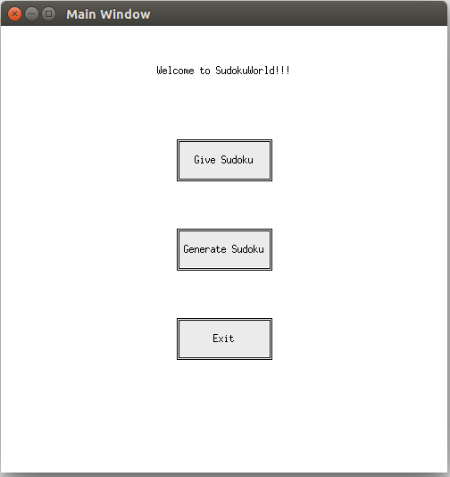

The main menu consists of 3 buttons which can be clicked using the mouse.

These are :

* “Give Sudoku”: This button takes the user to the “User Input Window”, which is used to submit problem Sudoku grids for the computer to solve.
* “Generate Sudoku” : This button takes the user to the “Generate Window”, which generates a Sudoku puzzle for the user of the required difficulty.
* “Exit”: This button exits the application.

1. User Input Window

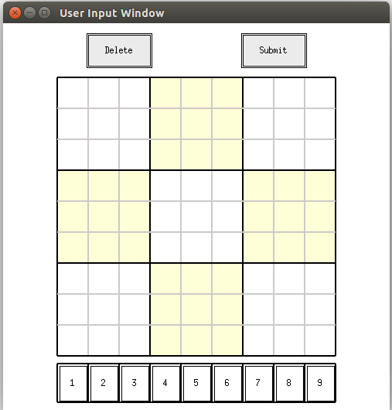

This window is used to input problem Sudokus for the computer to solve.

Numbers are filled by clicking the required number in the bar below and then clicking on the required square on the Sudoku.

Filled numbers can be deleted by using the same technique, but instead of the bar below, user has to press the “Delete” button and then the box, which they want to erase.

Obviously, trying to delete an already empty box will not do anything.

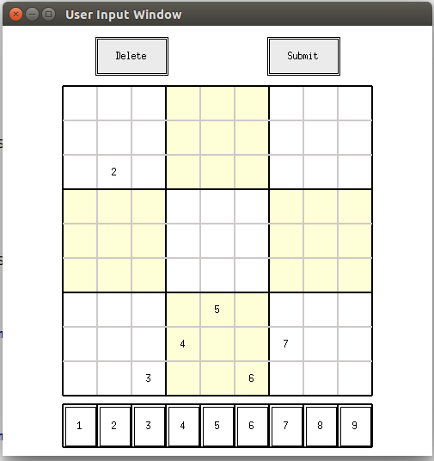

Inputting numbers , using the mouse.

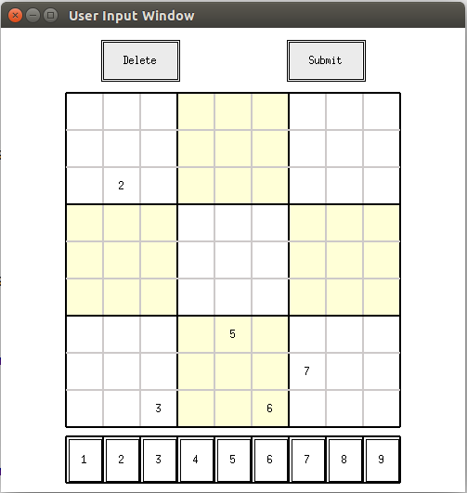

Using “Delete” on ‘4’in this example.

Clicking on “Submit”will take you to the "Solution Window“

Solution Window

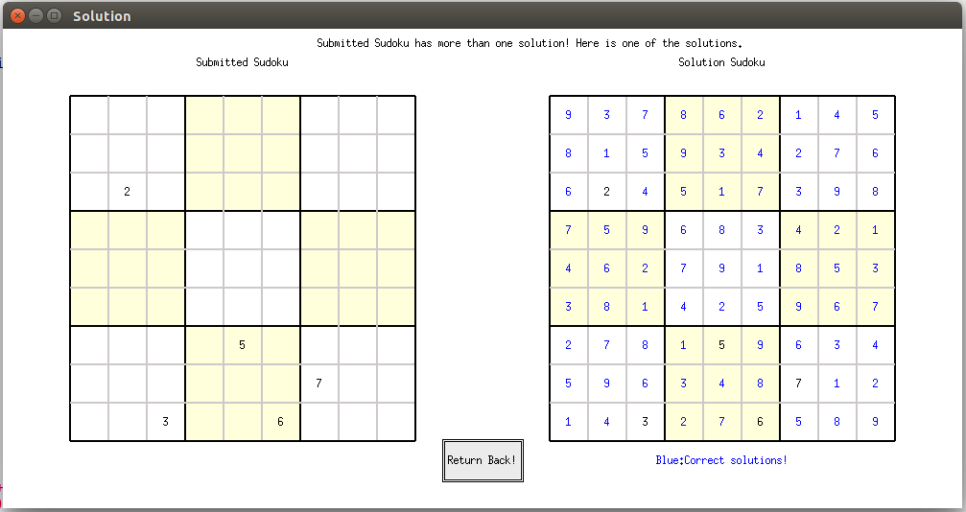

The solution window will either inform the user , about the number of solutions of the inputted Sudoku.

It will have either exactly one solution, in which case the computer will inform about only one solution and show the user the correct solution.

Otherwise, it may have more than one solutions possible, in which case the user will be informed about the same and shown one of the possible solutions.

Also, a case where no solution is present can occur. The program will inform the user about this, if that is the case.

The solutions to the inputted Sudoku will show in blue.

2. Generate Sudoku Window

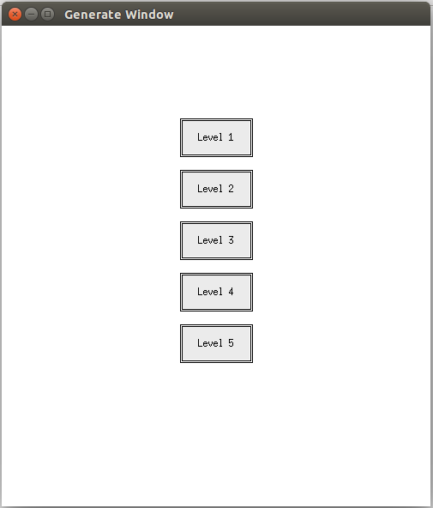

On clicking “Generate Sudoku” a new window will pop up, on which the user has to click the button corresponding to the level of difficulty they want.

A new screen with the generated Sudoku will appear.

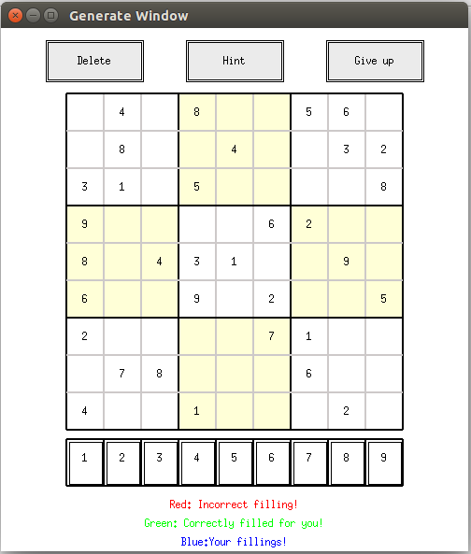

The digits of the question Sudoku will appear in black. The procedure to fill /delete numbers is same as that in User Input Window. User inputs will now be shown in blue.

A new button “Hint” appears , which is used to take hints from the computer. The number of hints you can take is a function of the level of difficulty you are playing.

The hint button will point out your mistake in red , if there are any. Pressing the hint button till an error marked in red is not changed will not do anything.

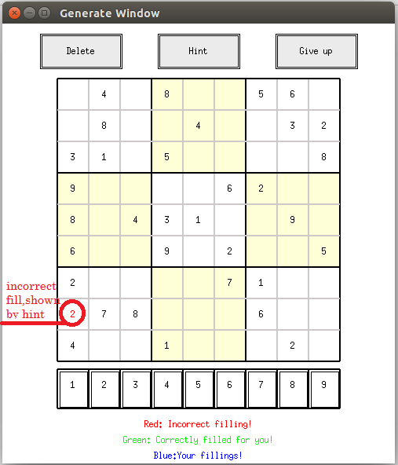

If your fillings are correct till the point to which you have filled the Sudoku, using the hint will give you a correct number revealed onto the Sudoku , randomly. Such numbers will be displayed in green.

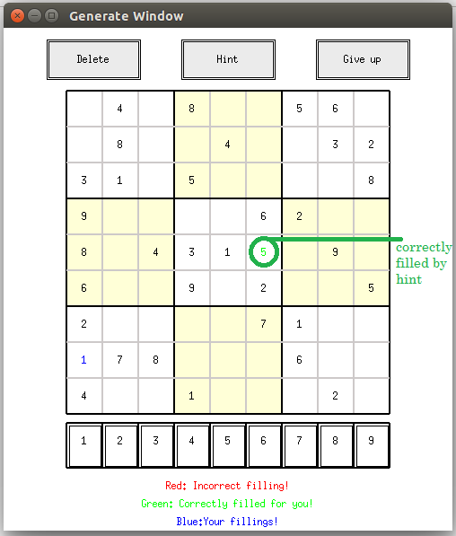

Once all the empty boxes have been filled up by the user, the Sudoku will auto submit, and be evaluated on the score screen.

If you are not able to solve it, you can “Give up”to view the solution.

Score Window

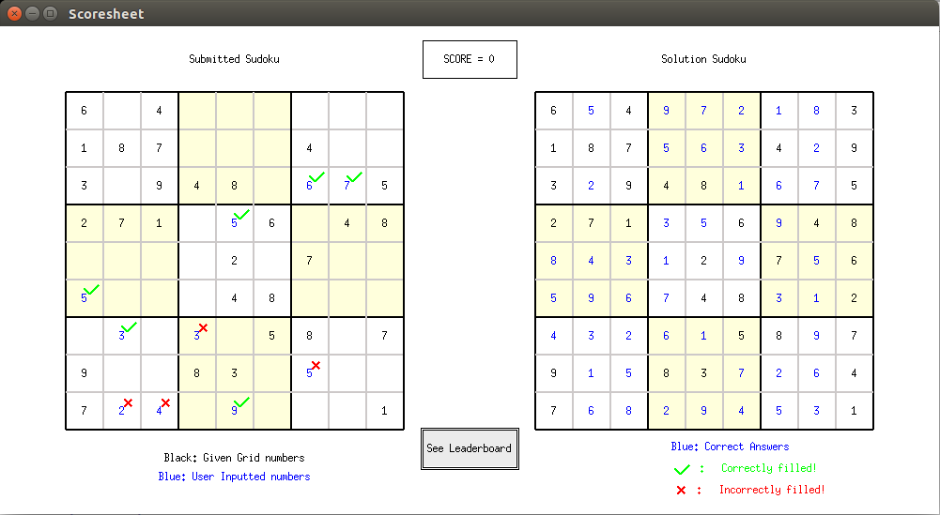

After the autosubmit/GiveUp , the score window will display. The user will be awarded ‘0’ score if the answer is incomplete or incorrect (even one mistake).

Otherwise your score will depend on the level of difficulty of the Sudoku, the time taken by the user and number of hints taken to solve it.

The left hand side will show the user the correct and wrong fillings they have done using green ticks or red crosses. The right hand side shows the correct solution of the problem.

Press the “LeaderBoard” to go to the next screen.

Leaderboard/ Submit Score

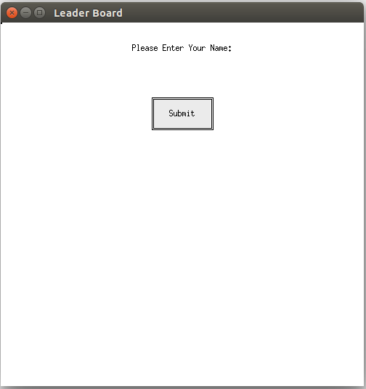 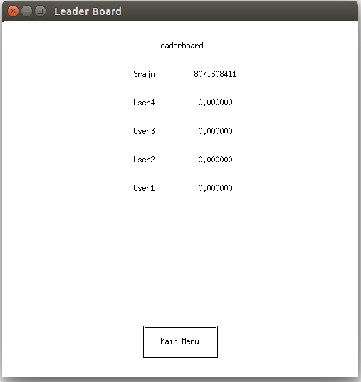

On pressing “Leader Board”, you will get a submit score screen. You can type in your name, use backspace and press submit or press enter to register your score.

The leader board will display the top scorers. You can return to the main menu from the button on the leaerboard screen.